Lesson 03 Demo 09

Azure Storage Explorer

Objective: To configure Storage Explorer for managing Azure storage accounts
Tools Required: None

Prerequisites: None

Steps to be followed:
- Install Azure Storage Explorer
- Connect to an Azure subscription

Step 1: Install Azure Storage Explorer

- Download and install Azure Storage Explorer https://azure.microsoft.com/features/storage-explorer/

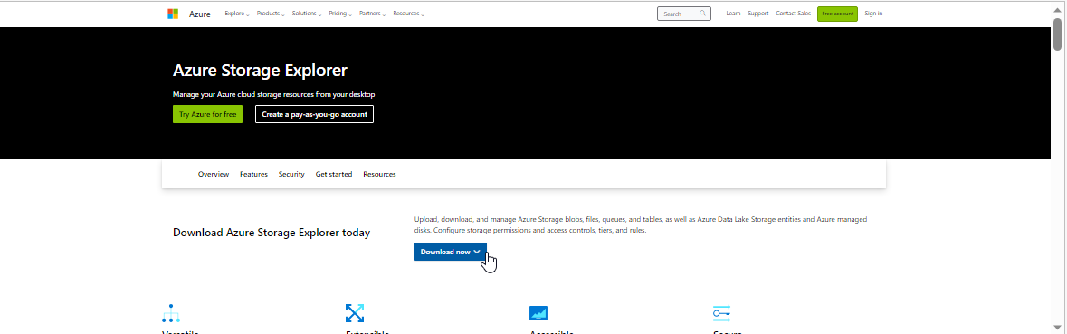

- After installation, launch the tool

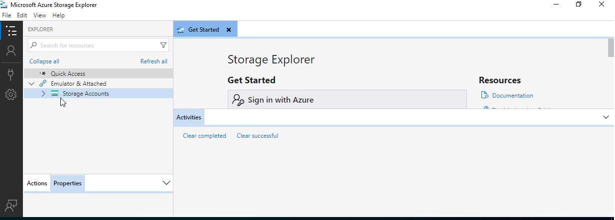

Step 2: Connect to an Azure subscription

  - In Storage Explorer, select Storage Accounts> Connect to Azure resource> Subscription

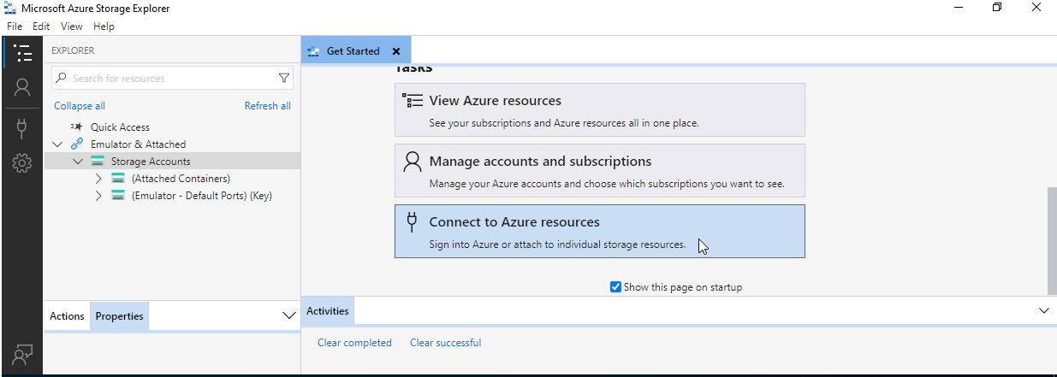

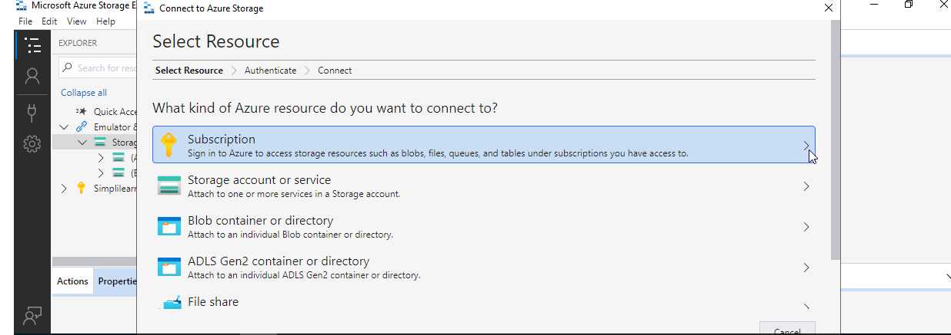

  - In the Select Azure Environment panel, select an Azure environment to sign in to. Then, select Next

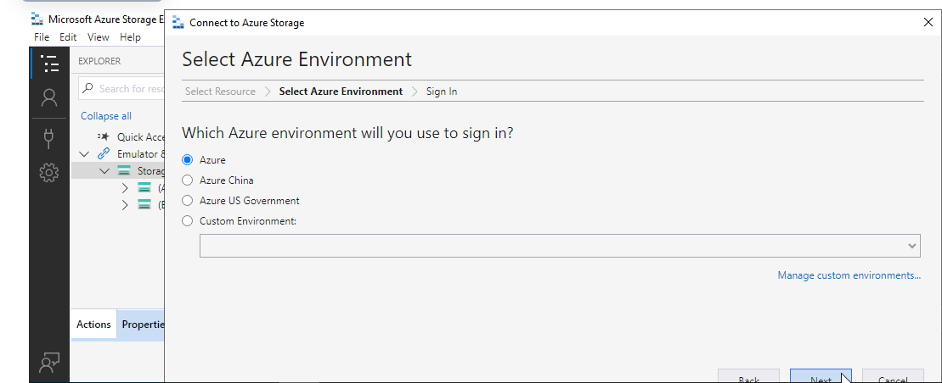

  - Storage Explorer will open a webpage for the user to sign in.

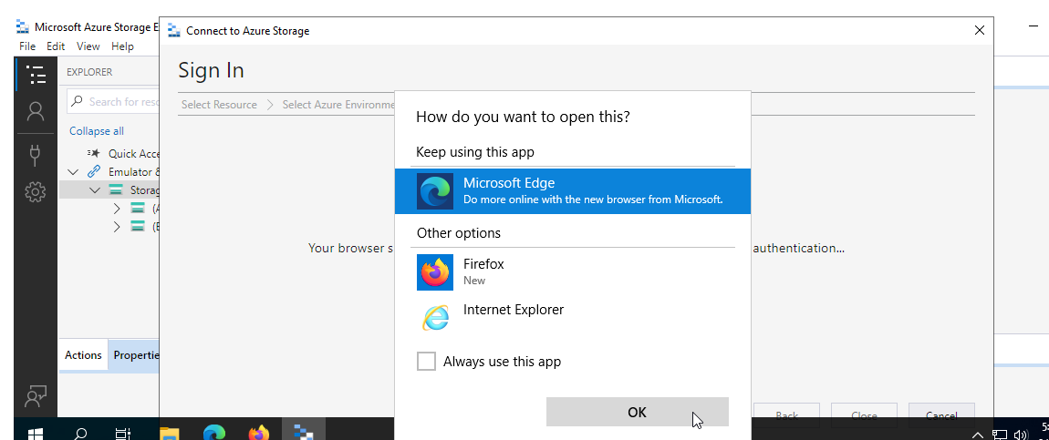

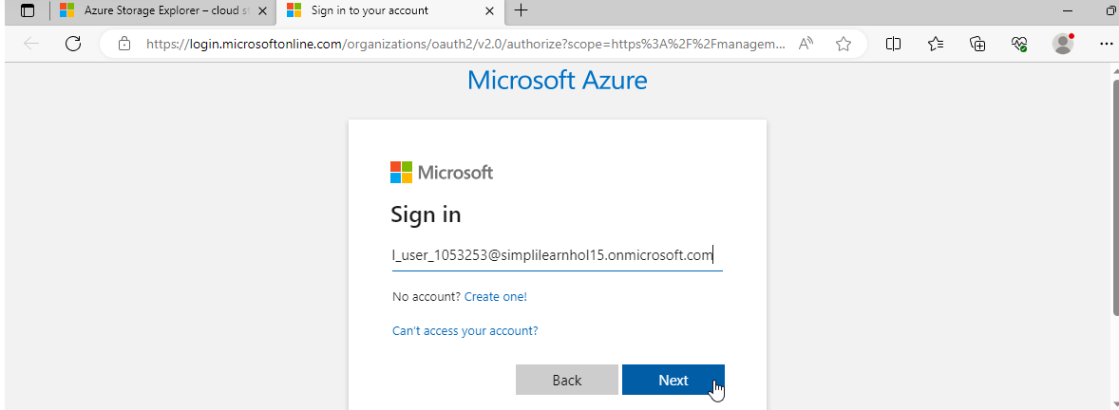

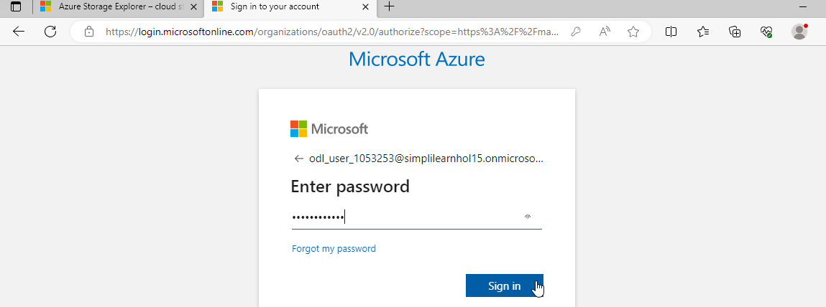

  - After the user successfully signs in with an Azure account, the account and the Azure subscriptions associated with that account appear under ACCOUNT MANAGEMENT. Click on Open Explorer

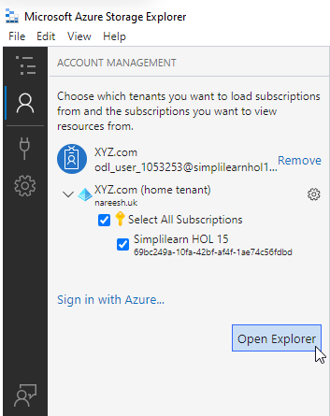

  - EXPLORER displays the storage accounts associated with the selected Azure subscriptions.

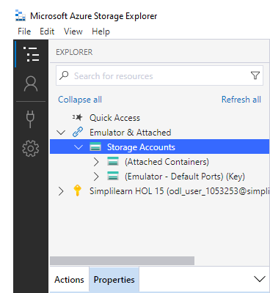

You have now successfully installed and used Azure Storage Explorer to manage users' Azure storage accounts.

